**Applications**

**1. Designing a cylindrical vessel using fmincon**

*Find the optimum value of height (h) and radius (r) of a cylinder to minimize its surface area such that it can hold a volume of 10 units*

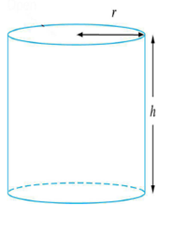

C:\Users\Nitin\AppData\Local\Temp\ConnectorClipboard6777457620054427948\image17057303711331.png

C:\Users\Nitin\AppData\Local\Temp\ConnectorClipboard6777457620054427948\image17057303711392.png

C:\Users\Nitin\AppData\Local\Temp\ConnectorClipboard6777457620054427948\image17057303711473.png

C:\Users\Nitin\AppData\Local\Temp\ConnectorClipboard6777457620054427948\image17057303711514.png

C:\Users\Nitin\AppData\Local\Temp\ConnectorClipboard6777457620054427948\image17057303711555.png

**2. Using ODE45 for Chemical Reactor Simulation**

*Compositions of three components (A, B, and C) in a reactor can be given by the following differential equations,*

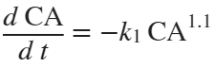

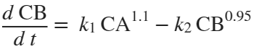

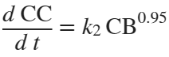

A -----> B ------> C

*Initial Conditions: at t = 0, CA=1; CB=0; CC=0. Solve the differential equations for the time span from t = 0 to 10 units.*

**3. Designing volume of a PFR**

Consider a liquid phase reaction, AàProduct. If the molar feed of A (FA0) to the PFR is 2 mol/s, what PFR volume is necessary to achieve 80% conversion? Note that the PFR design equation and the kinetic data are as follows

